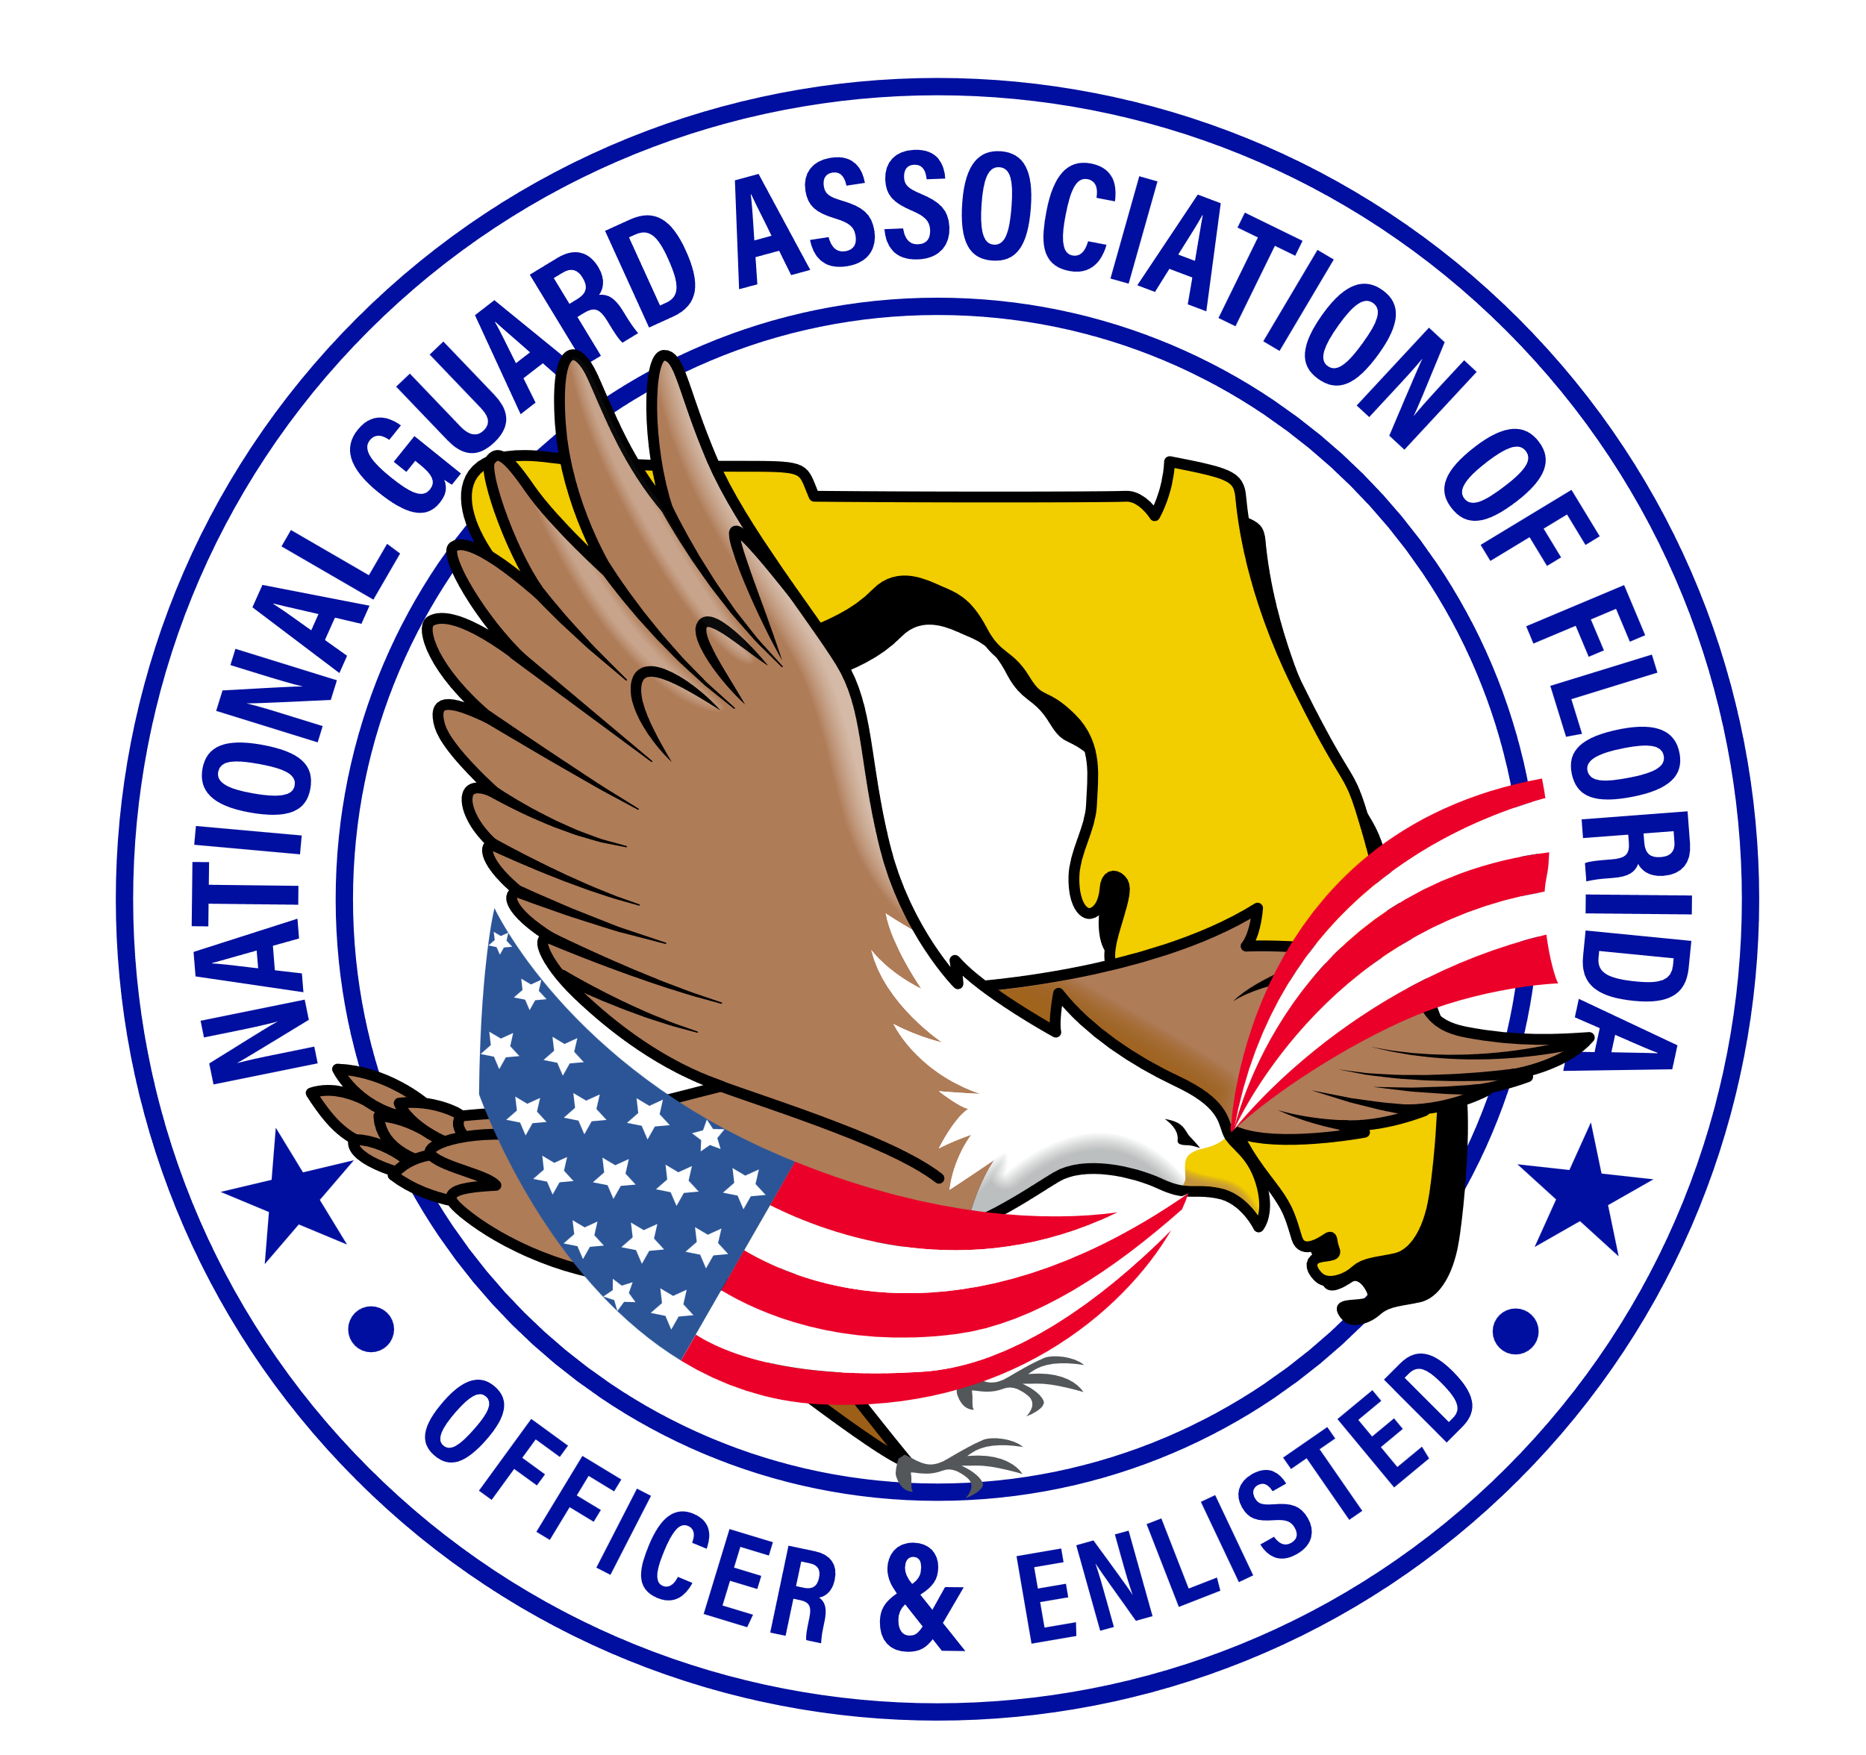

The National Guard Association of Florida, Inc.

PO Box 3446 St Augustine, FL 32085

(904)823-0628

carolynsmith@floridaguard.org

EANGUS Conference Committee,

Please find a Conference Host Packet attached. Florida is interested in hosting the EANGUS 2026 Conference in Daytona Beach July 26-30th. We want to host as an EANGUS Funded Conference. We met with the Ocean Center Convention Center and the Dayona Beach Hilton who would be the host hotel and has 700 rooms they are willing to put under contract. We have many places to hold events, the Bandshell would be a great location for the Jr. Enlisted & All States Night. The Hilton and Bandshell are both oceanfront facilities. The Ocean Center Convention center is right across Atlantic Ave from them so transportation need would be small. We have met with the city manager, city commissioner and state senator who are all willing to help make this a fantastic event. I have spoken with the Florida TAG & SEL and both are excited at the opportunity to host the conference.

Please find attached the Proposal from Daytona Beach Area Convention & Visitors Bureau, a letter from the City Manager, Budget.

Room rated offered $199.00 per night Single Occupancy, $219. Double Occupancy (State Per Diem) Resort fee included in rate, breakfast included. Taxes & $10.00 self-parking extra.

Daytona Beach Airport 4.5 miles away. Airlines: American, Delta, Virgin Atlantic, WestJet, Avelo

Sanford Airport (SFB) 40.9 miles away. Airlines: Allegiant, Sun Country, Flair Airlines

Orlando Airport (MCO)75.8 miles away. Airlines: All

RV Parks 2 with in 10 miles of convention center

Hospitality rooms: 7 hospitality Terrace rooms Comped. Yes, you can bring your own food and beverage. Refrigerator in room. Can rent bigger ones. Ice can be ordered through room service.

Transportation. The Hotel does not have a shuttle. We would need to contract transportation with bus service for airport shuttles, JR Enlisted Night (if at Baseball Field) and Golf.

Exhibit Hall has Space for 200+ Exhibits at the standard 10 x 10.

All States Night Could be held in the Daytona Band Shell, Daytona Hilton is Rain backup.

Welcome Night Daytona Bandshell, Hilton is rain backup.

Support Florida National Guard can provide,

Chaplin

Sergeant at Arms

Transportation POC

DG-VIP Support

Security

Medical

Honor Guard/ Color Guard

13 Army Band

Registration

Bag Stuffing

NGAFL Executive Council will assist with

Hotel Coordination, A

Please let me know what else you need from me.

Thank You

Carolyn Smith

Executive Director

National Guard Association of Florida, Inc.

(904)823-0628